**Case Study: Apple Transitioning from Intel to ARM**

**Submitted by:** Danica Marie A. Dumalagan

**Date Submitted:** May 4, 2023

The recent announcement by Apple Inc. to transition its line of desktop computers to its custom silicon, the M1, is a significant turning point in the desktop computing industry. The M1 is based on the ARMv8.5-A instruction set and offers industry-leading performance per watt and higher performance GPUs, according to Apple. This move is the second transition that Apple has made since the PowerPC to Intel x86 in 2006. So, what led to this decision by Apple to transition its desktop silicon from Intel to its custom SoC? There are a few factors at play here.

### Our own brand

Apple has been investing heavily in developing its own processors for several years. In 2008, the company acquired PA Semi, a fabless semiconductor design firm. This acquisition allowed Apple to begin designing its own processors for its mobile devices, which led to the development of the A-series chips used in iPhones and iPads.

### Moore’s law

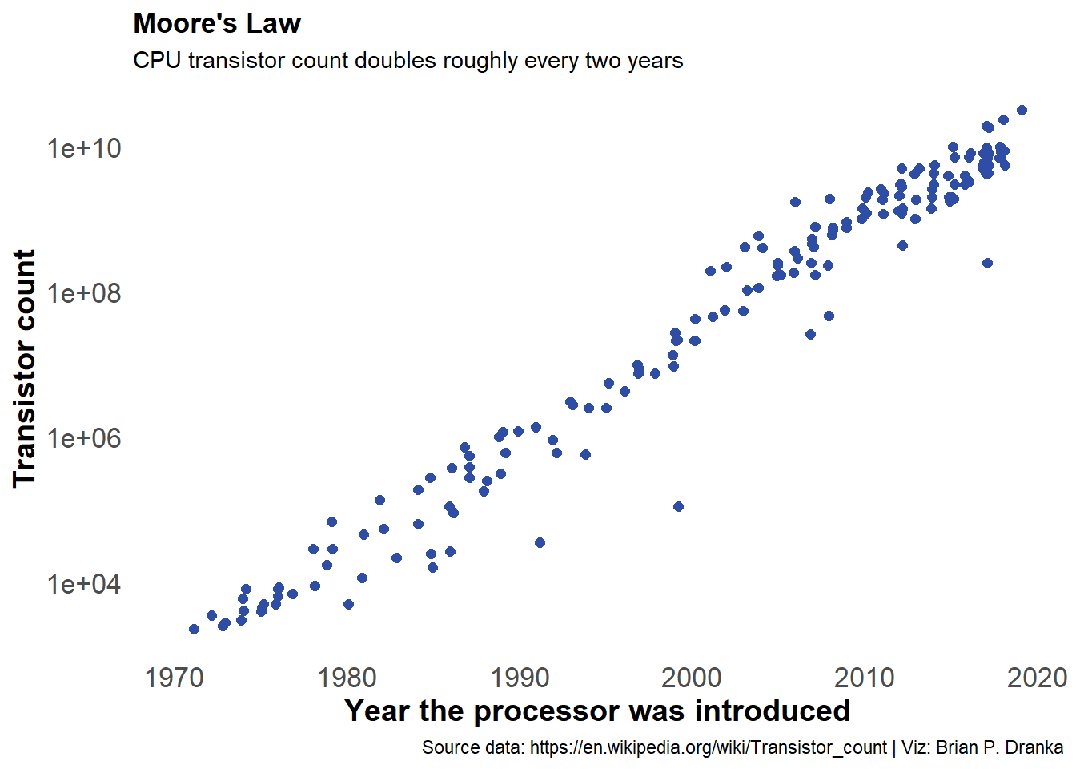

*“the number of transistors on a microchip doubles every two years”*

Intel has been struggling to keep up with Moore's Law, which states that the number of transistors on a chip doubles every two years. In recent years, Intel has struggled to deliver significant performance gains with each new processor generation. This has led to a slowdown in the rate of progress in the desktop computing industry.

### Architecture popul*[ARM]*ity

The rise and popularity of ARM architecture have made it an attractive alternative to x86 for desktop computing. ARM-based chips are known for their low power consumption and high performance, making them well-suited for use in mobile devices. However, the performance of ARM-based chips has traditionally lagged behind that of x86-based chips, which has limited their use in desktop computing.

Apple's M1 chip represents a significant leap forward in ARM-based computing. The M1 chip features an 8-core CPU, an 8-core GPU, and a 16-core Neural Engine. It is manufactured using a 5nm process, which allows for more transistors to be packed onto the chip, resulting in higher performance and lower power consumption.

In terms of performance, the M1 chip is comparable to high-end x86-based chips from Intel and AMD. In benchmark tests, the M1 chip outperforms many of Intel's and AMD's top chips in single-core performance while consuming less power. However, the M1 chip falls short in multi-core performance, where some of Intel's and AMD's top chips still have an edge.

### So, what does this mean for the desktop computing industry?

So, what does this mean for the desktop computing industry? It's too early to say for sure, but it's clear that Apple's transition to its custom silicon represents a significant shift in the industry. If the M1 chip lives up to its promises, it could lead to a new era of high-performance, low-power computing that could challenge the dominance of x86-based chips in the desktop computing market.

### The risk Apple is willing to take.

However, it's important to note that Apple's transition to its custom silicon is not without risks. One major risk is that developers may be slow to port their applications to the new architecture, which could lead to compatibility issues for Mac users. Additionally, some users may be hesitant to switch to an ARM-based Mac, given the long history of x86-based Macs.

### In conclusion

In conclusion, Apple's transition to its custom silicon represents a major turning point in the desktop computing industry. The M1 chip offers industry-leading performance per watt and higher performance GPUs, which could lead to a new era of high-performance, low-power computing. However, this transition is not without risks, and it remains to be seen how developers and users will react to the new architecture.

### References

D. Burrows, “10 biggest product recalls of all time,” *Kiplinger.com*, 26-Mar-2018. [Online]. Available: https://www.kiplinger.com/slideshow/investing/t052-s000-10-biggest-product-recalls-of-all-time/index.html. [Accessed: 14-Apr-2023].

E. Lyle Long, “8 most notorious defective products in recent history [U.S. edition],” *Long, Jean & Wechsler, P.A.*, 31-Mar-2023. [Online]. Available: https://ljwlegal.com/notorious-defective-products/. [Accessed: 14-Apr-2023].